UNIX PROGRAMMING WEEK 3 ASSIGNMENT
NISARGA VISHWAMANJUSWAMY
- Chapter 8, do programming project 1 on page 178.
Programming project 1: repdigic.c

#include <stdbool.h>
#include <stdio.h>

int main(void) {
bool digit_seen[10] = {false};
bool digit_repeated[10] = {false};
int digit;
long n;

printf("Enter a number: ");
scanf("%ld", &n);

while (n > 0) {
digit = n % 10;
if (digit_seen[digit]) {
digit_repeated[digit] = true;
} else {
digit_seen[digit] = true;
}
n /= 10;
}

bool has_repeats = false;
printf("Repeated digit(s): ");
for (int i = 0; i < 10; i++) {
if (digit_repeated[i]) {
printf("%d ", i);
has_repeats = true;
}
}

if (!has_repeats) {
printf("No repeated digits\n");
} else {
printf("\n");
}

return 0;
}

OUTPUT : 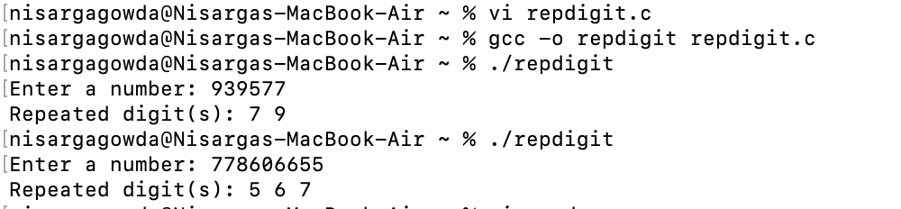

- Chapter 8, do Programming Projects 9 and 16 on page 179, page 180, and page 181.

Programming Projects 9 : random.c

#include <stdio.h>
#include <stdlib.h>
#include <time.h>
#include <stdbool.h>

#define SIZE 10

bool is_valid_move(int x, int y, char grid[SIZE][SIZE]) {
return (x >= 0 && x < SIZE && y >= 0 && y < SIZE && grid[x][y] == '.');
}

void print_grid(char grid[SIZE][SIZE]) {
for (int i = 0; i < SIZE; i++) {
for (int j = 0; j < SIZE; j++) {
printf("%c ", grid[i][j]);
}
printf("\n");
}
}

int main(void) {
char grid[SIZE][SIZE];
int x = SIZE / 2, y = SIZE / 2;
char current_char = 'A';

for (int i = 0; i < SIZE; i++) {
for (int j = 0; j < SIZE; j++) {
grid[i][j] = '.';
}
}

srand((unsigned)time(NULL));
grid[x][y] = current_char++;

while (true) {
int direction = rand() % 4;
int new_x = x;
int new_y = y;

switch (direction) {
case 0: new_x--; break;
case 1: new_x++; break;
case 2: new_y--; break;
case 3: new_y++; break;
}

if (is_valid_move(new_x, new_y, grid)) {
x = new_x;
y = new_y;
grid[x][y] = current_char++;

if (current_char > 'Z') {
break;
}
} else {
int blocked = 0;
for (int i = 0; i < 4; i++) {
int check_x = x;
int check_y = y;
switch (i) {
case 0: check_x--; break;
case 1: check_x++; break;
case 2: check_y--; break;
case 3: check_y++; break;
}
if (!is_valid_move(check_x, check_y, grid)) {
blocked++;
}
}
if (blocked == 4) {
break;
}
}
}

print_grid(grid);
return 0;
}

OUTPUT:
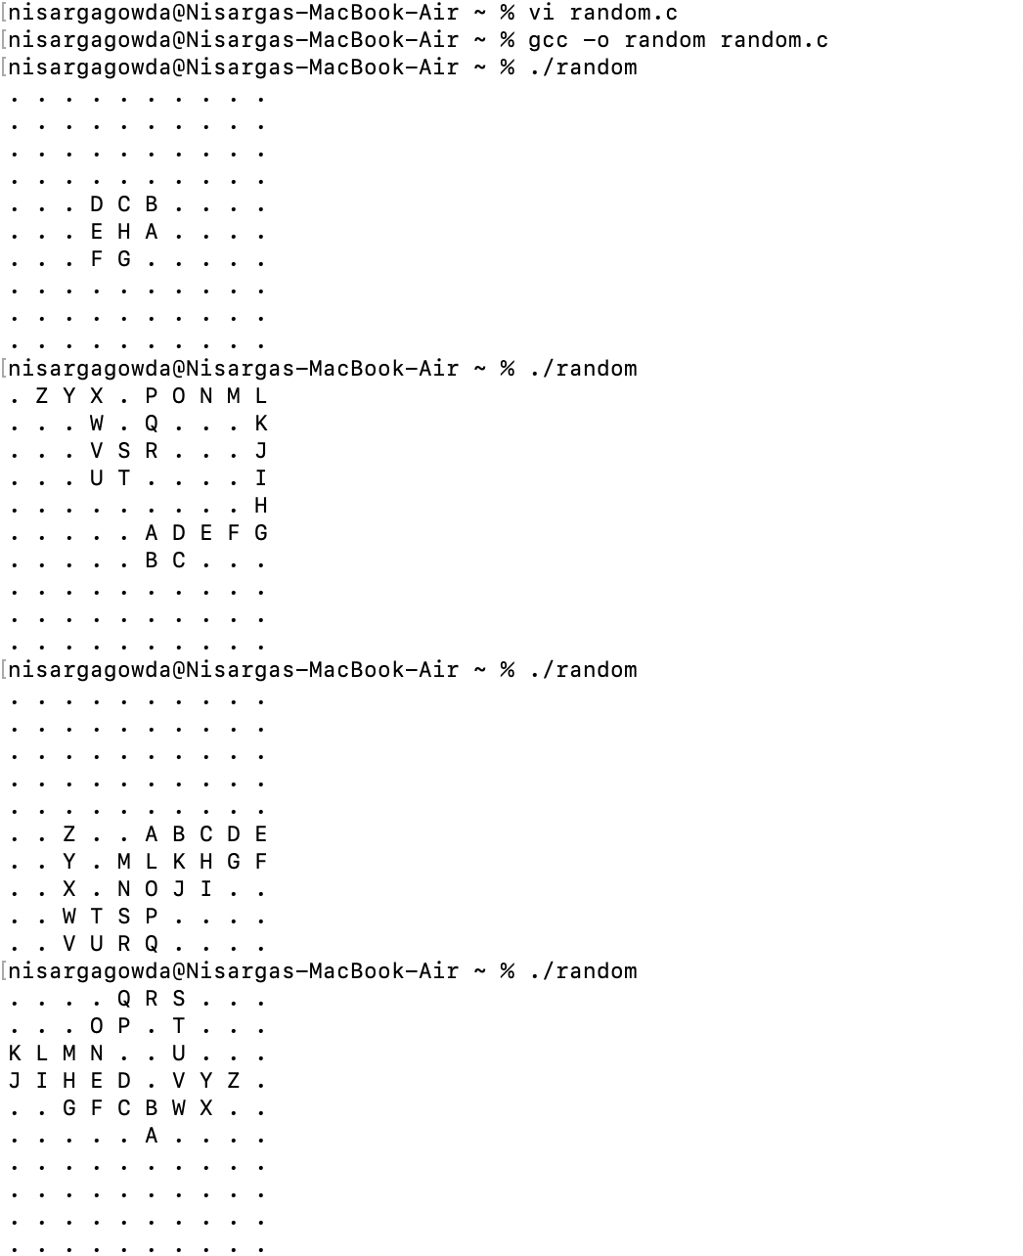

Programming Projects 9: anagram.c

#include <stdio.h>
#include <ctype.h>
#include <string.h>

#define ALPHABET_SIZE 26

void count_letters(const char *word, int counts[ALPHABET_SIZE], int increment) {
while (*word) {
if (isalpha(*word)) {
int index = tolower(*word) - 'a';
counts[index] += increment;
}
word++;
}
}

int main(void) {
char word1[100], word2[100];
int letter_counts[ALPHABET_SIZE] = {0};

printf("Enter first word: ");
fgets(word1, sizeof(word1), stdin);
word1[strcspn(word1, "\n")] = '\0';

count_letters(word1, letter_counts, 1);

printf("Enter second word: ");
fgets(word2, sizeof(word2), stdin);
word2[strcspn(word2, "\n")] = '\0';

count_letters(word2, letter_counts, -1);

for (int i = 0; i < ALPHABET_SIZE; i++) {
if (letter_counts[i] != 0) {
printf("The words are not anagrams.\n");
return 0;
}
}

printf("The words are anagrams.\n");
return 0;
}

OUTPUT:
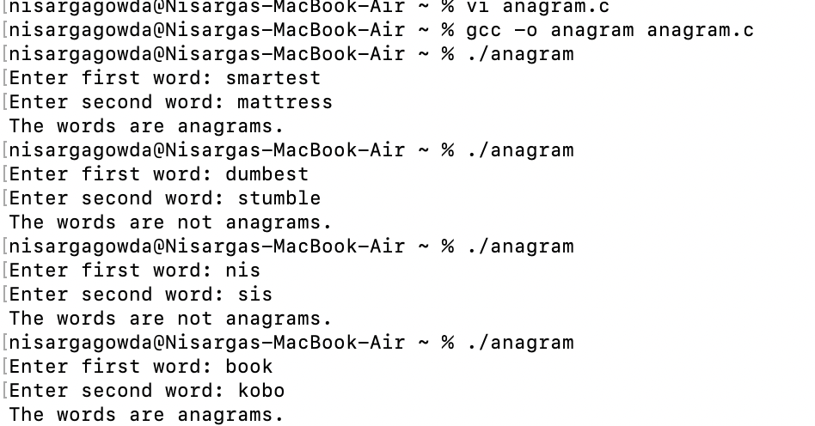

- Chapter 9, do exercise 1 on page 214.

Exercise 1:
The function that is provided contains two errors related to the syntax and declaration of parameters.
1. Parameter Declaration: The parameter height is not declared with a type. Both parameters should specify their types.
2. Variable Declaration: The variable product should be declared inside the function's body, not after the parameter list.

double triangle_area(double base, double height) {
double product;
product = base * height;
return product / 2;
}

Execution code : triangle.c

#include <stdio.h>

double triangle_area(double base, double height) {
double product;
product = base * height;
return product / 2;
}

int main(void) {
double base, height;

printf("Enter the base of the triangle: ");
scanf("%lf", &base);
printf("Enter the height of the triangle: ");
scanf("%lf", &height);

double area = triangle_area(base, height);
printf("The area of the triangle is: %.2f\n", area);

return 0;
}

OUTPUT:
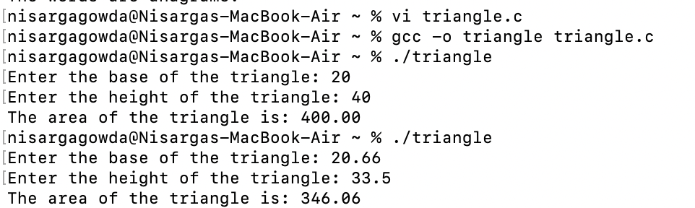

- Chapter 9, do Programming Project 4 on page 217.

Programming Project 4: wordcount.c

#include <stdio.h>
#include <ctype.h>
#include <string.h>
#include <stdbool.h>

#define ALPHABET_SIZE 26

void read_word(int counts[ALPHABET_SIZE]) {
char word[100];
printf("Enter a word: ");
fgets(word, sizeof(word), stdin);
word[strcspn(word, "\n")] = '\0';

for (int i = 0; word[i] != '\0'; i++) {
if (isalpha(word[i])) {
int index = tolower(word[i]) - 'a';
counts[index]++;
}
}
}

bool equal_array(int counts1[ALPHABET_SIZE], int counts2[ALPHABET_SIZE]) {
for (int i = 0; i < ALPHABET_SIZE; i++) {
if (counts1[i] != counts2[i]) {
return false;
}
}
return true;
}

int main(void) {
int letter_counts1[ALPHABET_SIZE] = {0};
int letter_counts2[ALPHABET_SIZE] = {0};

read_word(letter_counts1);
read_word(letter_counts2);

if (equal_array(letter_counts1, letter_counts2)) {
printf("true\n");
} else {
printf("false\n");
}

return 0;
}

OUTPUT:
